AmioWavPack Version 2.2

WavPack Plugin for Adobe Audition CC Version
David Bryant
January 25, 2026

1.0 Introduction

This plugin allows you to load and save files in the WavPack format. It will work with Adobe Audition version 4 (also known as CS5.5) and version 5 (also known as CS6). For other versions of Adobe Audition or Cool Edit, other plugins are available on the WavPack website.

It supports reading and writing both pure lossless and hybrid WavPack files (with correction files) and all bit depths, including Audition's native 32-bit floating point. It supports any number of channels (with Abode identities) and all sampling rates. There is no limit on the size of the audio file. WavPack files containing DSD audio can be loaded as 24-bit PCM decimated 8x for use, but DSD files cannot be written. The WavPack plugin now supports “realtime” reading so that there's no a longer a delay when loading WavPack files (except the first time a fresh file is loaded, just like WAV).

Also, extra information like cue and play lists, artist/title information, EBU extensions and even bitmaps can be stored and retrieved in WavPack files. If the source file contains metadata items in either ID3v1 or APEv2 tags (the standard for WavPack files), these are held by Audition and may be rewritten when the file is saved.

2.0 Installation

To install the plugin, copy (or extract) the file "AmioWavpack.amio" into the "Plug-ins/Amio" directory starting at the Audition executable, and then restart Audition. Normally, this would be somewhere like one of these:

C:\Program Files\Adobe\Adobe Audition CS6\Plug-Ins\Amio\
C:\Program Files (x86)\Adobe\Adobe Audition CS5.5\Plug-Ins\Amio\

3.0 Usage

Loading WavPack files works just like loading any other format. Note that files from before WavPack 4.0 can be loaded, but these files are deprecated and may be unusable in future versions of this plugin. A warning dialog will display when loading these files. When loading WavPack files the first time there will be a delay as Audition scans the file for peak levels, but after that the file should load as quickly as native WAV files. If the source file contains metadata items in either ID3v1 or APEv2 tags, these are held by Audition. Although they are not visible nor editable, they may be rewritten when the file is saved back to WavPack.

To save an audio file in the WavPack format, use the “Save As...” or “Export As...” menu items and select “WavPack” in the “Format” drop down list. You should see something like this:

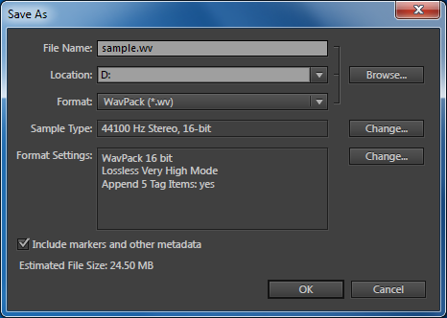

You can change the sampling rate and bit depth here. To change the “Format Settings” that are specific to WavPack, click the “Change...” button to the right of them and a dialog like this should appear:

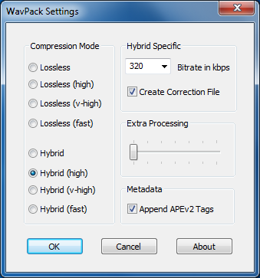

From here it's possible to configure the following WavPack-specific settings:

Compression Mode:
- Lossless – This is the default mode and provides a decent compromise between compression ratio and speed.
- Lossless (high) – This mode provides better compression in WavPack, but is somewhat slower than the default mode both in saving and loading files.
- Lossless (v-high) – This mode provides the highest possible compression in WavPack, but is significantly slower than the default mode both in saving and loading files and is not recommended for files to be played on hardware devices.
- Lossless (fast) – This mode provides the fastest operation with somewhat less compression.
- Hybrid – This enables the "hybrid" mode of WavPack (which can be either lossless or lossy depending on the creation of the "correction" file).
- Hybrid (high) – This is the high quality version of the hybrid mode which provides higher quality lossy files and somewhat smaller correction files, but at some cost in speed.
- Hybrid (v-high) – This is the highest quality version of the hybrid mode which provides higher quality lossy files and somewhat smaller correction files, but at significant cost in speed. This mode is not recommended for files to be played on hardware devices.
- Hybrid (fast) – This mode provides the fastest hybrid operation.

Hybrid Specific:
- Bitrate in kbps – This is where you select the target bitrate of the hybrid file in kbps; the values range from the minimum possible for the current file up to a reasonable maximum using standard bitrates (although you may type in a custom value if you like). If you are not able to get a bitrate as low as you'd like, you could go back and reduce the sampling rate.
- Create Correction File – This option enables the creation of the "correction" file (extension .wvc) that stores the information that is discarded in creating the lossy file and may be used later, in conjunction with the lossy file, for lossless operation.

Extra Processing:
This slider selects the amount of extra processing used to improve the compression ratio and, in hybrid mode, the quality of the resulting lossy file. This is equivalent to the -x mode of the command-line encoder, and does not affect the decoding speed of the target file. When the slider is all the way to the left (0) no extra processing is done and the fastest possible operation is performed. The rightmost position (6) causes an exhaustive search for the best compression parameters and is very slow. In some cases this extra processing can significantly improve the compression ratio, especially for "non-standard" files like those containing synthesized signals or those at very high or very low sampling rates.

Metadata:
- Append APEv2 Tags – Write the metadata items read from the original source file to the destination file as an APEv2 tag.

4.0 Known Bugs

- RIFF metadata contained in “bext” chunks are not read from WavPack files that were written by other applications (or converted from WAV). This is the “Broadcast Extension Information”. If this data is written from Audition directly to a WavPack file, it will be preserved when loading back into Audition, but will not accessible to other applications.
- If the user aborts a save to the WavPack format that includes a correction file (.wvc) being overwritten, the original correction file will be lost (the lossy part will be okay).

5.0 History

- Version 1.0 - Initial release
- Version 1.1 - Fix crash on invoking compression dialog (Audition CS5.5)
- Version 1.2 - Enhancements and fixes to saving of multichannel files (beyond 5.1)
- Version 1.3 - Performance improvements from assembly optimizations (WavPack 4.75)
- Version 1.4 - Fixes from WavPack 4.75.2 library code (creating corrupt files)
- Version 1.5 - Update to WavPack 4.80.0 library code and Amio SDK revision 1.2
- Version 2.0 - Update to WavPack 5.0.0 library code (and many new features)
- Version 2.1 - Update to WavPack 5.1.0 library code
- Version 2.2 - Fix issues with very long files (>4G samples), WavPack 5.9.0

6.0 Summary / Credits

WavPack and this plugin are free programs; feel free to give them to anyone who may find them useful. There is no warranty provided and you agree to use them completely at your own risk. If you have any questions or problems please post at the Hydrogen Audio WavPack forum:

https://hydrogenaud.io/index.php/board,68.0.html

The latest version of this plugin and information on Wavpack is available at the WavPack website:

http://www.wavpack.com/

Many thanks to the team at Adobe for inviting me to participate!

